AZURE DEVOPS

What is Azure DevOps?

Azure DevOps is a cloud-based set of tools and services provided by Microsoft that helps development and operations teams collaborate, plan, build, test, and deploy software more efficiently.
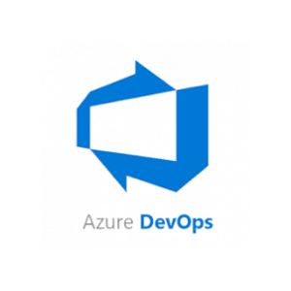

It supports the full DevOps lifecycle, making it easier to manage the entire software development process—from writing code to delivering it into production.
- DevOps = Development + Operations: Azure DevOps brings together developers and IT operations teams for faster and more reliable software delivery.

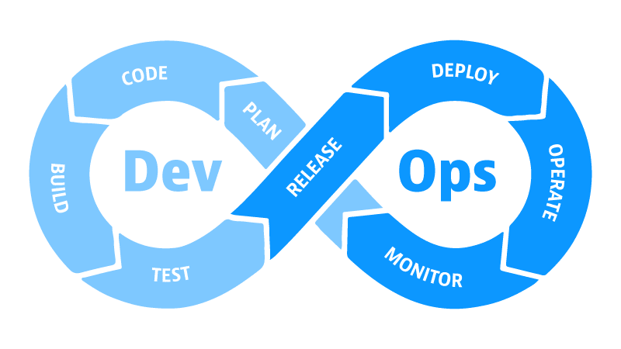

- Cloud and On-Premises: You can use Azure DevOps Services (cloud version) or Azure DevOps Server (on-premises version).

- Services in Azure DevOps

Azure DevOps provides a suite of 5 core services, each covering a crucial part of the software development lifecycle. These tools are fully integrated but can also be used independently based on your team’s needs.That are:
1.Azure Boards
2.Azure Repos
3.Azure Pipelines
4.Azure TestPlans
5.Azure Artifacts

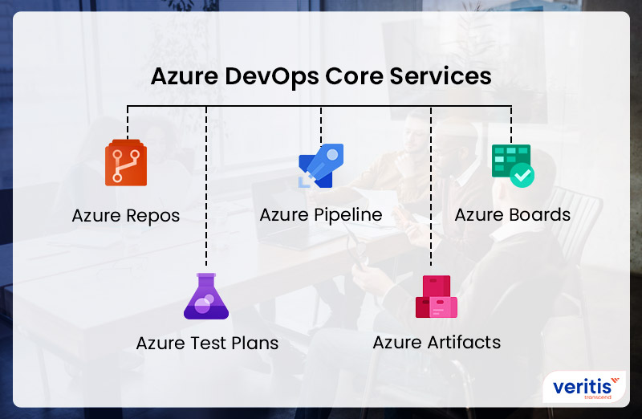

- What is the purpose of Azure DevOps?
Azure DevOps is built to simplify the software development lifecycle (SDLC) by offering an integrated set of tools. Its main purpose is to help teams:
- It Track the changes in the code
- Plan the project (requirements, tasks, and tracking).
- Develop and version their code.
- Test the application automatically.
- Build and deploy continuously.
- Monitor and improve based on feedback.
- It acts as a central platform where developers, testers, project managers, and operations teams collaborate effectively.

Why Do We Need Azure DevOps?
Here’s why organizations choose Azure DevOps:

All-in-One DevOps Platform:
- No need to manage multiple disconnected tools. Azure DevOps includes:
- Azure Boards (planning & tracking)
- Azure Repos (code management)
- Azure Pipelines (CI/CD automation)
- Azure Artifacts (package sharing)
- Azure Test Plans (manual & automated testing)

2. Automates Repetitive Tasks (CI/CD):
- Builds and tests code every time someone pushes changes.
- Delivers updates to production environments automatically.
- Saves time, reduces errors.

3. Improved Team Collaboration
- Assign tasks to team members via Boards.
- Review and approve code through pull requests.
- Track bugs, feature requests, and progress in real time.

4. Cloud-Based and Scalable:
- Access your projects from anywhere.
- Easy to scale from a small team to enterprise-level.

5. Security and Compliance:
- Role-based access control (RBAC).
- Integration with Azure Active Directory.
- Compliance with industry standards.

What Did We Use Before Azure DevOps?
Before Azure DevOps, software teams used a mix of different tools, which often caused issues such as:
- Tool Integration Problems: Tools had to be manually connected
- Multiple Logins: Each tool required separate credentials.
- Inconsistent User Experience: Different UI/UX across tools.
- Time-Consuming Maintenance: Teams had to update and manage tools manually.
Tools commonly used before Azure DevOps:
- Jenkins for CI/CD
- GitHub/Bitbucket for source code
- Jira for project tracking
- Selenium/TestNG for testing
- Trello/Excel for task tracking

Azure DevOps vs Traditional DevOps
Before platforms like Azure DevOps, teams had to piece together different tools. Here’s a comparison:
Feature | Azure DevOps | Traditional DevOps (Manual Setup)
Project Management | Azure Boards | Jira, Trello
Code Repository | Azure Repos | GitHub, Bitbucket
CI/CD Pipeline | Azure Pipelines | Jenkins, Travis CI
Testing Tools | Azure Test Plans | Selenium, TestNG, Postman
Package Management | Azure Artifacts | Artifactory, Nexus
Integration Effort | Minimal (all tools in one) | High (manual configuration required)
Maintenance | Microsoft handles cloud services | You manage upgrades, backups, monitoring
Learning Curve | Smoother for beginners | Steep—need to learn multiple tools separately

- Advantages After Switching to Azure DevOps:

- Unified Platform – All DevOps tools under one roof.
- Faster Setup – Minimal manual configuration needed.
- Improved Productivity – Developers spend more time coding, less time managing tools.
- End-to-End Traceability – You can trace a feature from task to deployment.
- Built-in Analytics – Dashboards show progress, deployment success, and code health.
- Better Communication – Everyone stays on the same page.

- Explanation of toolset in Azure DevOps:

Azure DevOps provides a suite of 5 core services, each covering a crucial part of the software development lifecycle. These tools are fully integrated but can also be used independently based on your team’s needs.

- Azure Boards – Work Tracking and Project Management:

Azure Boards is a powerful Agile project management tool for tracking work items, bugs, user stories, and features.
Features:
- Kanban boards and scrum boards
- Custom workflows for tracking bugs, tasks, and issues
- Dashboards and charts to visualize progress
- Sprints and backlogs for sprint planning and tracking velocity

Use Case:
Teams use Azure Boards to manage their day-to-day tasks, plan sprints, track bugs, and measure project progress.

Azure Repos – Source Code Management

Azure Repos provides Git-based version control for your source code. It helps teams collaborate on code by allowing branching, merging, and pull requests.
- Git repositories (distributed version control)
- TFVC (Team Foundation Version Control) for centralized versioning (legacy support)
- Pull requests for code reviews
- Branch policies for enforcing workflows
Use Case:
Developers push their code to Azure Repos, review each other’s code via pull requests, and maintain a history of all changes.
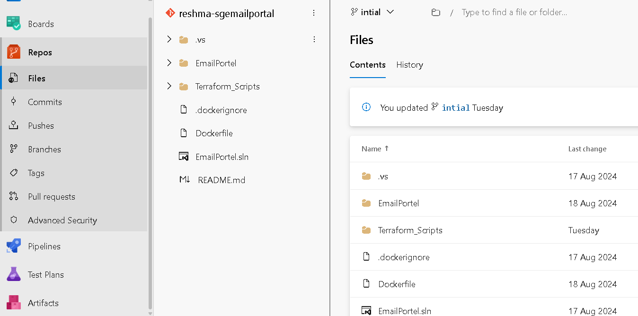

Azure Pipelines – CI/CD Automation

Azure Pipelines is a CI/CD (Continuous Integration and Continuous Delivery) tool. It automates the process of building, testing, and deploying code to different environments.
Features:
- Support for multiple languages (Java, .NET, Node.js, Python, etc.
- Multi-platform builds (Windows, Linux, macOS)
- Classic Editor (GUI-based) and YAML pipelines
- Integration with GitHub, Bitbucket, Docker Hub, etc.
- Automated deployments to Azure, AWS, GCP, or on-premise
- Classic Editor means Graphical user Interfaces.
- YAML is a text file or code based file.
Use Case:
Every time code is pushed to the repo, Azure Pipelines automatically builds the code, runs tests, and deploys it to a testing or production environment.

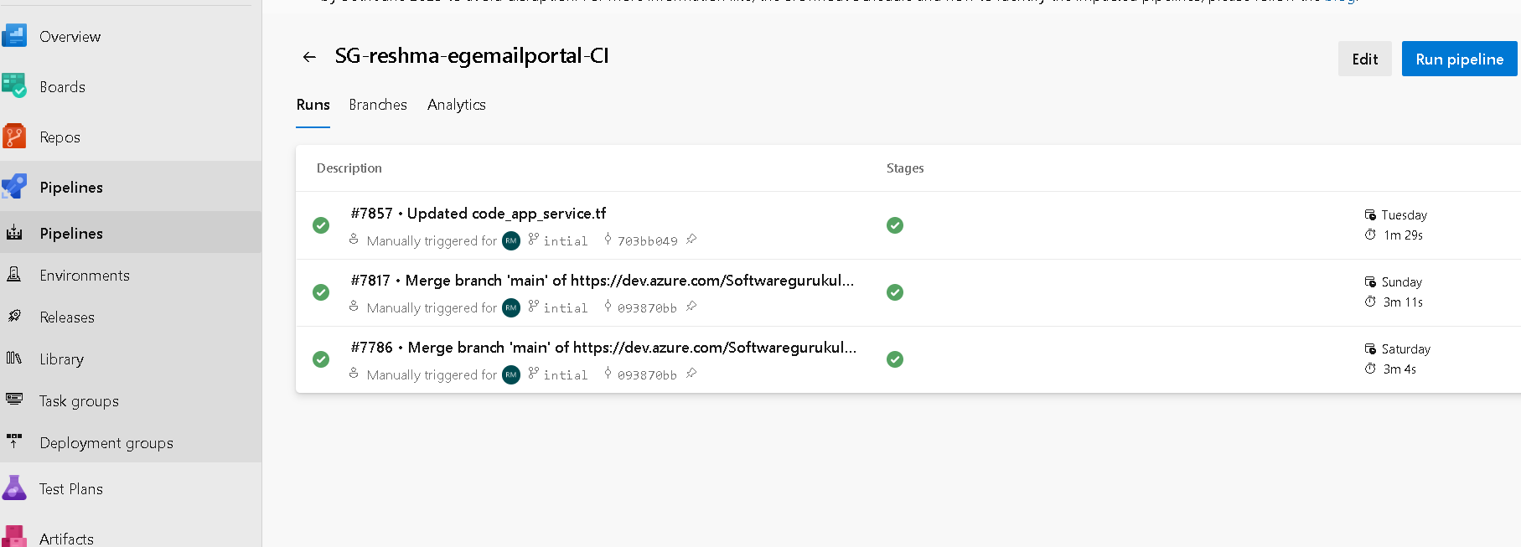

Azure Test Plans – Manual and Automated Testing

Azure Test Plans provides a comprehensive testing toolkit for manual and exploratory testing.
Features:
- Create and run test cases
- Track and report test results
- Conduct exploratory testing
- Integrates with Azure Pipelines for automated test results
Use Case:
Testers can define test cases and run them against builds to ensure quality before release. Test Plans integrate directly into your CI/CD pipeline for quality control.
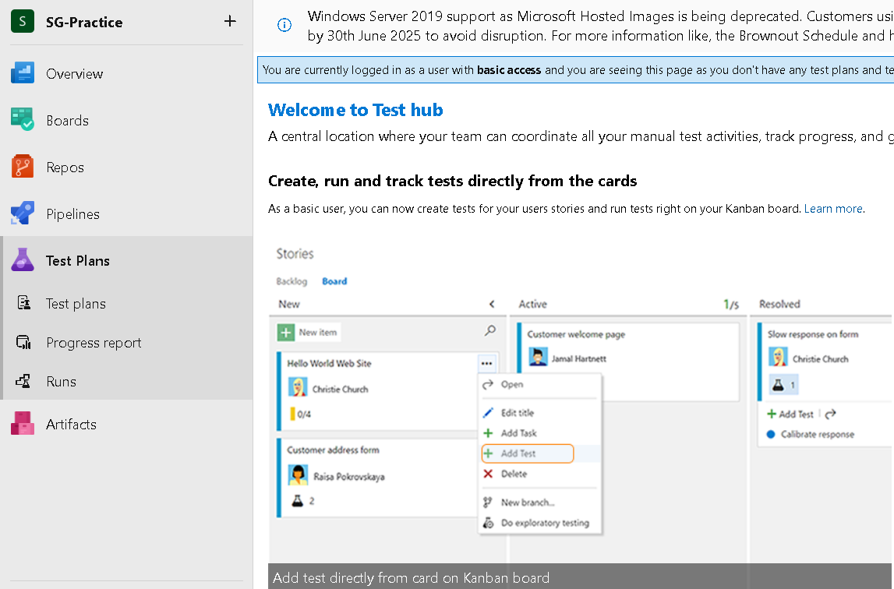

Azure Artifacts – Package Management

Azure Artifacts is used for creating, hosting, and sharing packages like libraries or dependencies used in your code.
Features:
- Supports npm, NuGet, Maven, Python, and Universal packages
- Scoped feeds for team or organization-level sharing
- Versioning and security policies for dependency management
Use Case:
If your app depends on custom libraries or packages, you can store and manage them using Azure Artifacts, and reference them in your builds.

